

Asia Pacific College

**“Alulong”**

Prepared and Submitted by:

Flores, Ivan Emmanuel

Rabo, Michael Angelo

Regalado, Guiler Marion

Verde, Jose Norberto

Presented to:

Batayola III, Charlemagne K.

Contents

**Revision History** iii

**Game Overview** 1

Project Description: 1

Review of Related Literature 2

**Main Features** 3

Feature 1 3

Feature 2 3

Feature 3 4

Feature 4 4

# **Revision History**

|  |  |  |  |
| --- | --- | --- | --- |
| **Author** | **Date** | **Details** | **Version** |
| Ivan Flores  Guiler Regalado  Michael Rabo  Jose Verde | December 20-21, 2022 | Initial Concept Creation for the game “Alulong” | 1.0 |
| Guiler Regalado  Jose Verde  Michael Rabo  Ivan Flores | January 13, 2023 | Mockups for Features | 1.1* |
|  |  |  |  |

# **Game Overview**

## Project Description:

“Alulong” is a 2D platformer game that allows its players within the game to explore and fight monsters revolving on Philippine Mythology. It borrows themes and gameplay mechanics from popular games like Super Mario Bros. and Hollow Knight, which are also known for being 2D platformer games. The plot of the game follows a man who is currently looking for his wife that was abducted by Sitan and his 4 agents of evil, which was taken from Philippine Myth. As of writing this game document, the gameplay mechanics of “Alulong” focuses on “World Levels” similar to Super Mario Bros. and having a landscape similar to Hollow Knight. The player’s goal is to reach the end of the level wherein they would fight 1 of the 4 Agents of Sitan. For the combat system of the game, the players at the start use their handy “Arnis” in defeating common enemies like the “Aswang” and “Tiyanak” that would try to stop the player from reaching the endpoint for the certain level. As the player progresses, more common enemies are added such as the “Tikbalang” and the “Manananggal” in future levels. At the end of each level, the main character fights a mini boss which are the 4 Agents of Sitan with each Agent having their own boss mechanic. If defeated, the mini bosses will drop a new weapon that the main character can use to easily go through the next levels. Upon reaching the last level, the main character now fights the Final Boss which is Sitan.

## Review of Related Literature

As a classic platformer, many currently known platformers take inspiration from the one and only Super Mario franchise, taking the basic mechanic of a platformer where the player gets through a level via a sequence of platform obstacles to conquer in multiple different worlds and world stages, and then putting their own twist into their game, like Hollow Knight and Dead Cells.

What makes Hollow Knight and Dead Cells, and other similar Metroidvania games, different is how the player navigates through a world level/stage. One can drift off from the usual one way only to get to the exit and be able to explore the world level/stage to discover new doorways that lead to new, and sometimes secret, segments within the world level/stage. Hollow Knight and Dead Cells use this to encourage the player to explore the level/stage to find items that will help the player, fight more creatures to gain more XP, etc., and not to mention how addictive the combat can be in both Hollow Knight and Dead Cells.

The creatures in Philippine mythology are quite interesting and fitting for the Metroidvania sub-genre wherein players fight creatures of myth. Philippine mythological creatures such as the Tikbalang, Manananggal, Tiyanak, etc. can be easily seen as worthy creatures for the player to encounter and fight in Metroidvania games, maybe in fighting-platformers in general.

References:

Aguilar, C. (2020, February 20). *Five reasons why you should play dead cells*. Destructoid. Retrieved December 21, 2022, from https://www.nintendo.destructoid.com/5-reasons-why-you-should-play-dead-cells-nintendo-switch/

Barokandtakya. (2021, June 13). *11 scariest Filipino mythical creatures to look out for*. Bisaya Podcast. Retrieved December 21, 2022, from https://barokandtakya.com/11-scariest-filipino-mythical-creatures-to-look-out-for/

Whitaker, J. (2021, October 1). *Review: Hollow knight*. Destructoid. Retrieved December 21, 2022, from https://www.destructoid.com/reviews/review-hollow-knight/

# **Main Features**

## Feature 1

* **A toy robot holding an object

  Description automatically generated with low confidence**Weapon

**Weapon** it is an equipment of player to defeat all the enemies called aswang. The weapon is disguised as a bracelet like gold chain that wrapped around his wrist. This chain can transform into different weapons like sword, bow, and spear.

**Function**

**Sword** – Whenever the player uses this weapon it can only attack the enemy in a shorter range.

**Bow –** Player can use this weapon in an enemy who is in long range. It can use also to the enemy with a flying type like mananggal.

**Spear -** Player can use this in both longer and shorter range. They can throw it like a bow, or they can also use this as a sword.

## Feature 2

* Enemy

**

**Enemy -** every stage has an enemy in order to have a combat system. We have common enemies and mini boss in every final stage of world.

**Function**

**Common enemy –** The common enemy in our game is commonly aswang, tiyanak, and manananggal. Since they are the most famous mythological creatures in the Philippines. They used to attack in a shorter range and every stage they can be more aggressive than the previous stage.

**Mini boss/Boss –** In every final stage of the world the player has a chance to have a boss fight and this boss will drop an item and give it to the player in order to unlock some weapons.

## Feature 3

* 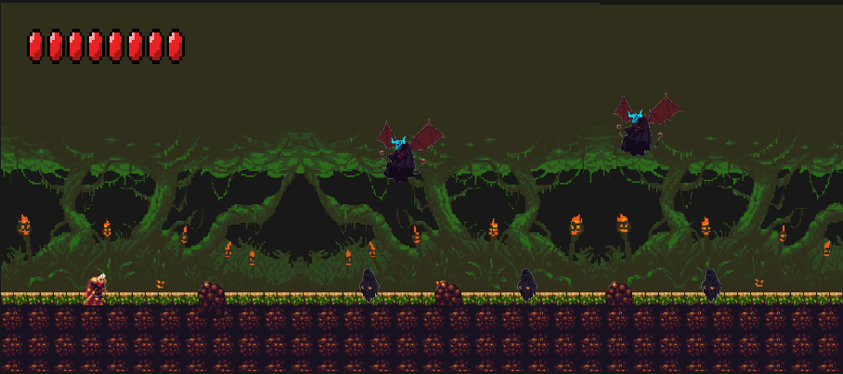Place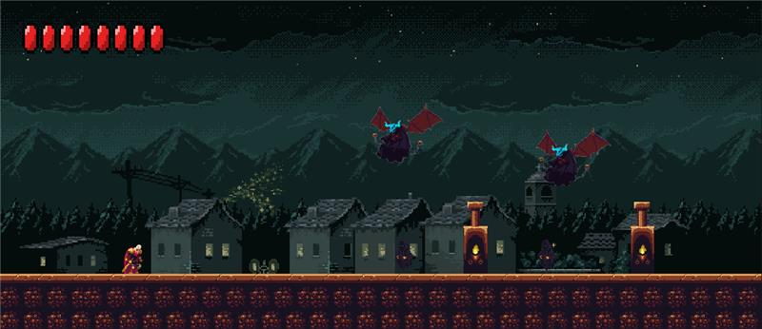

**Place** this is where all the stages where located we have 3 places, and all of the places is the common hideout of the aswang.

**Function**

**Forest -** This is where the first world located since the aswang are most likely hiding in this place waiting for them pray to come out.

**Cave -** This is also a hiding place of all many of the aswang they usually hiding here when it is morning. It is also the place where the gate to the underworld is located.

**Underworld –** This is the place where the powerful enemy is hiding it is called Sitan.

## Feature 4

* Occasionally, enemies may drop items that the player can use during the game. In-game, there are 2 kinds of drops: Health Potions and Arrows.

**Function**

**Health Potion** – When a health potion is consumed/used by the player, the player will then be healed, restoring 25 hp to their current health status.

**Arrow/s** – The ammunition that the Bow weapon will consume when used.

